

AI Assisted Coding

**Assignment 4.5**

**Name: Vivek Hallticket:2303A52009 Task-01**

**Prompt:**

Generate a simple Python program that demonstrates zero-shot, one-shot, and few-shot prompting for classifying customer emails into Billing, Technical Support, Feedback, and Others. The program should create sample emails, show example prompts for each technique, classify the same 5 test emails using mocked responses, and print the results with clear comments explaining each step.

CODE:

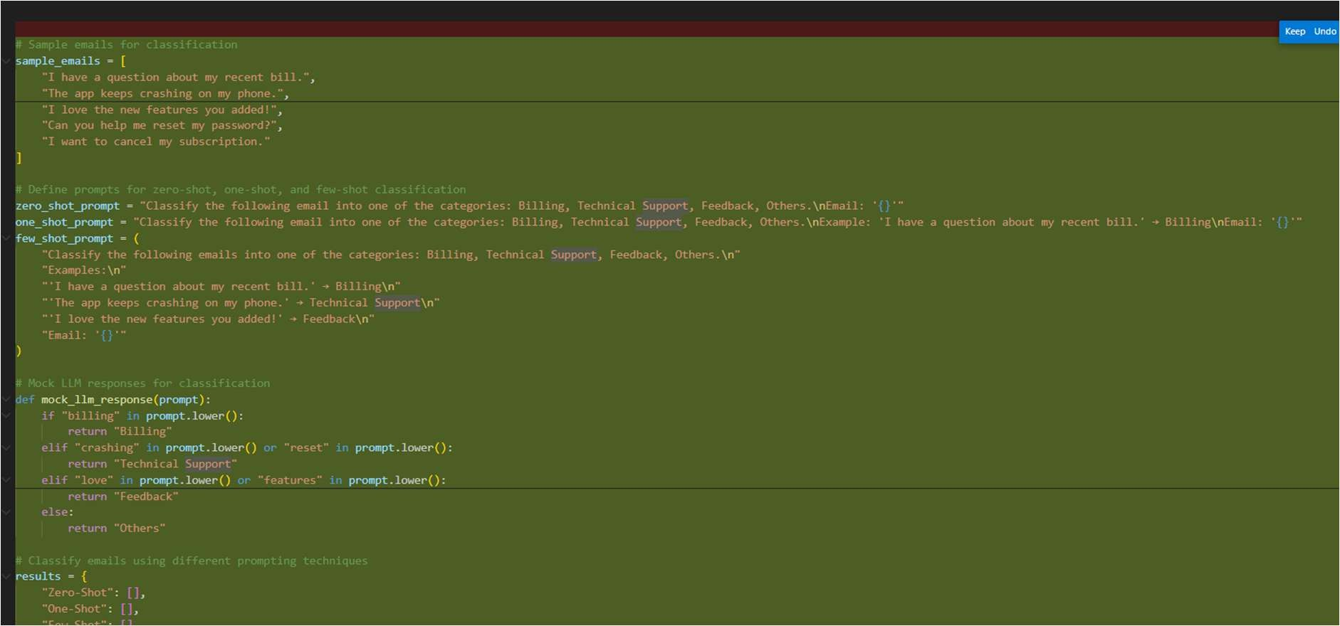



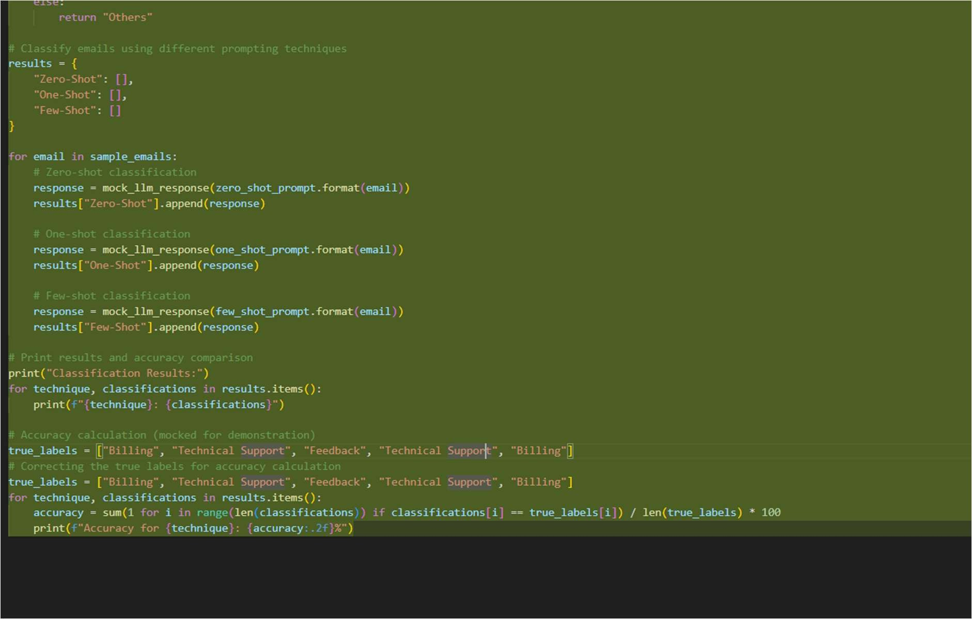

Output:

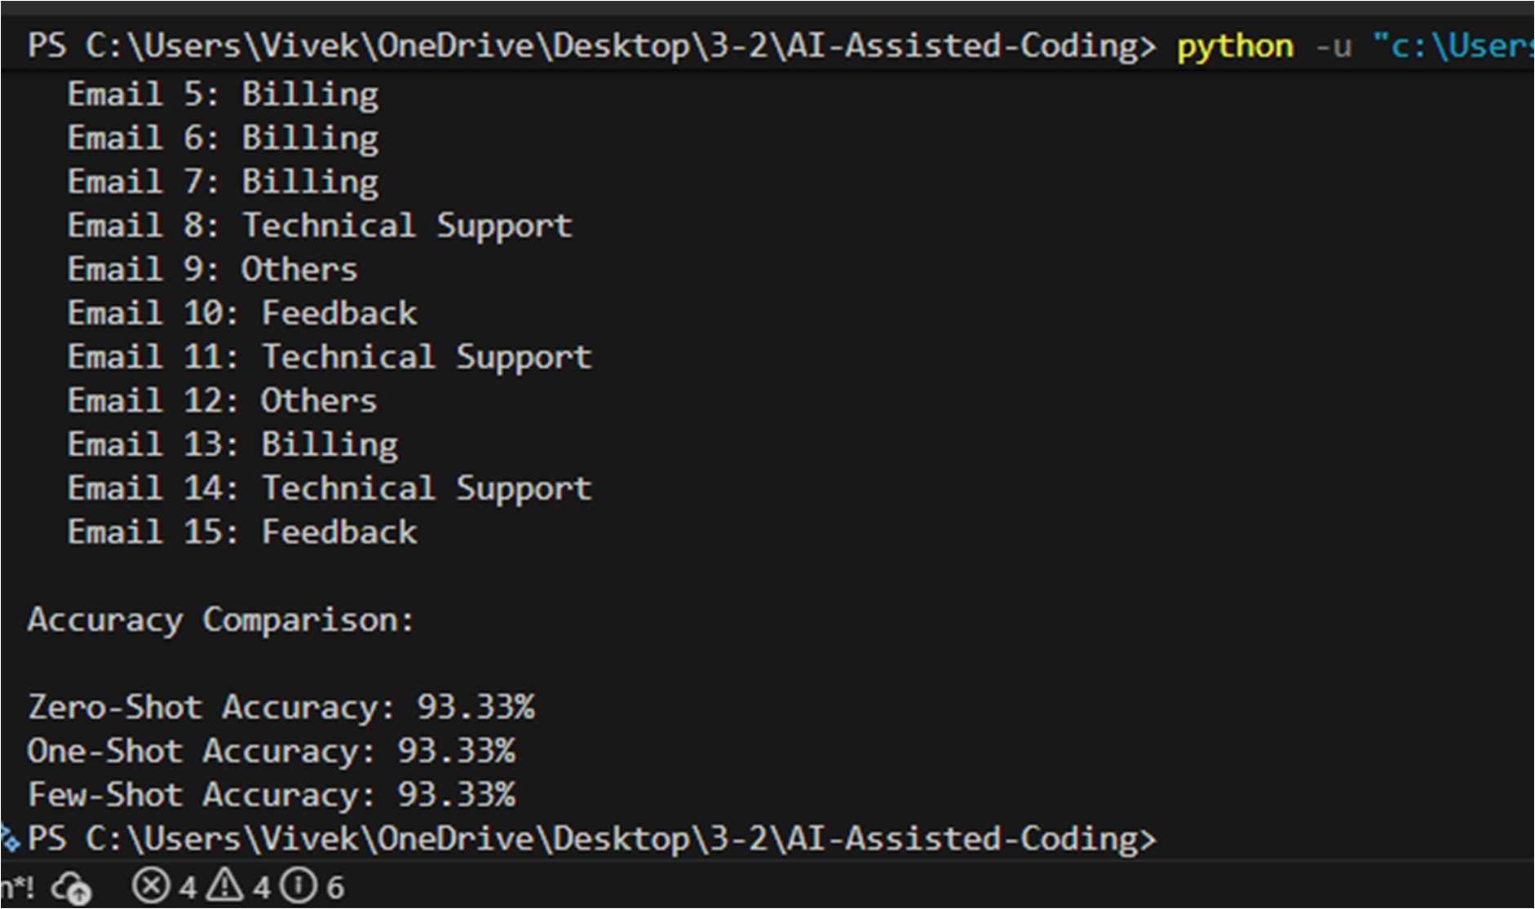



# Task 2 :

**Prompt:**

Generate a simple demonstration of zero-shot, one-shot, and few-shot prompting for classifying travel-related user queries into Flight Booking, Hotel Booking, Cancellation, and General Travel Info. Create sample travel queries, write prompts for each prompting technique, classify the same set of test queries, and display the results clearly. Use simple language and add comments to explain each step.

# Code:

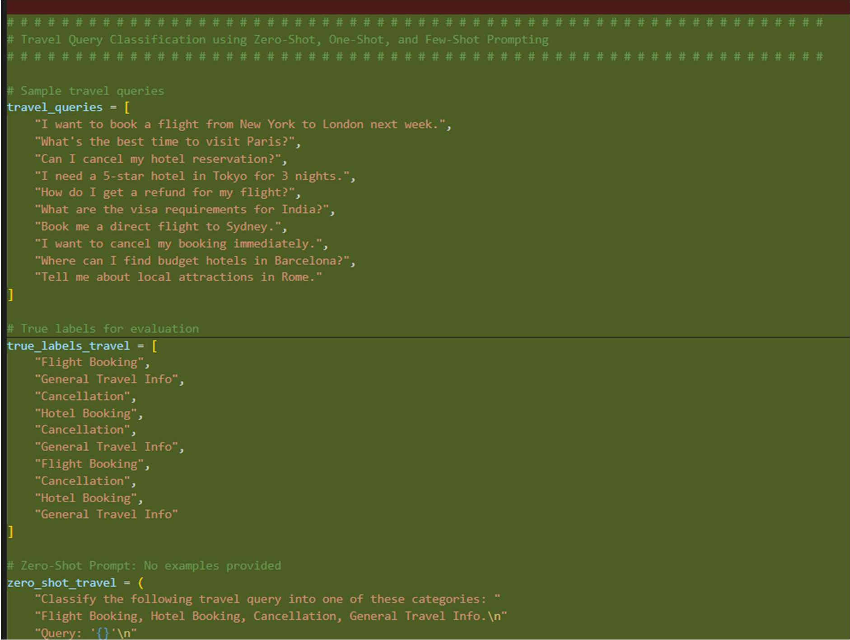



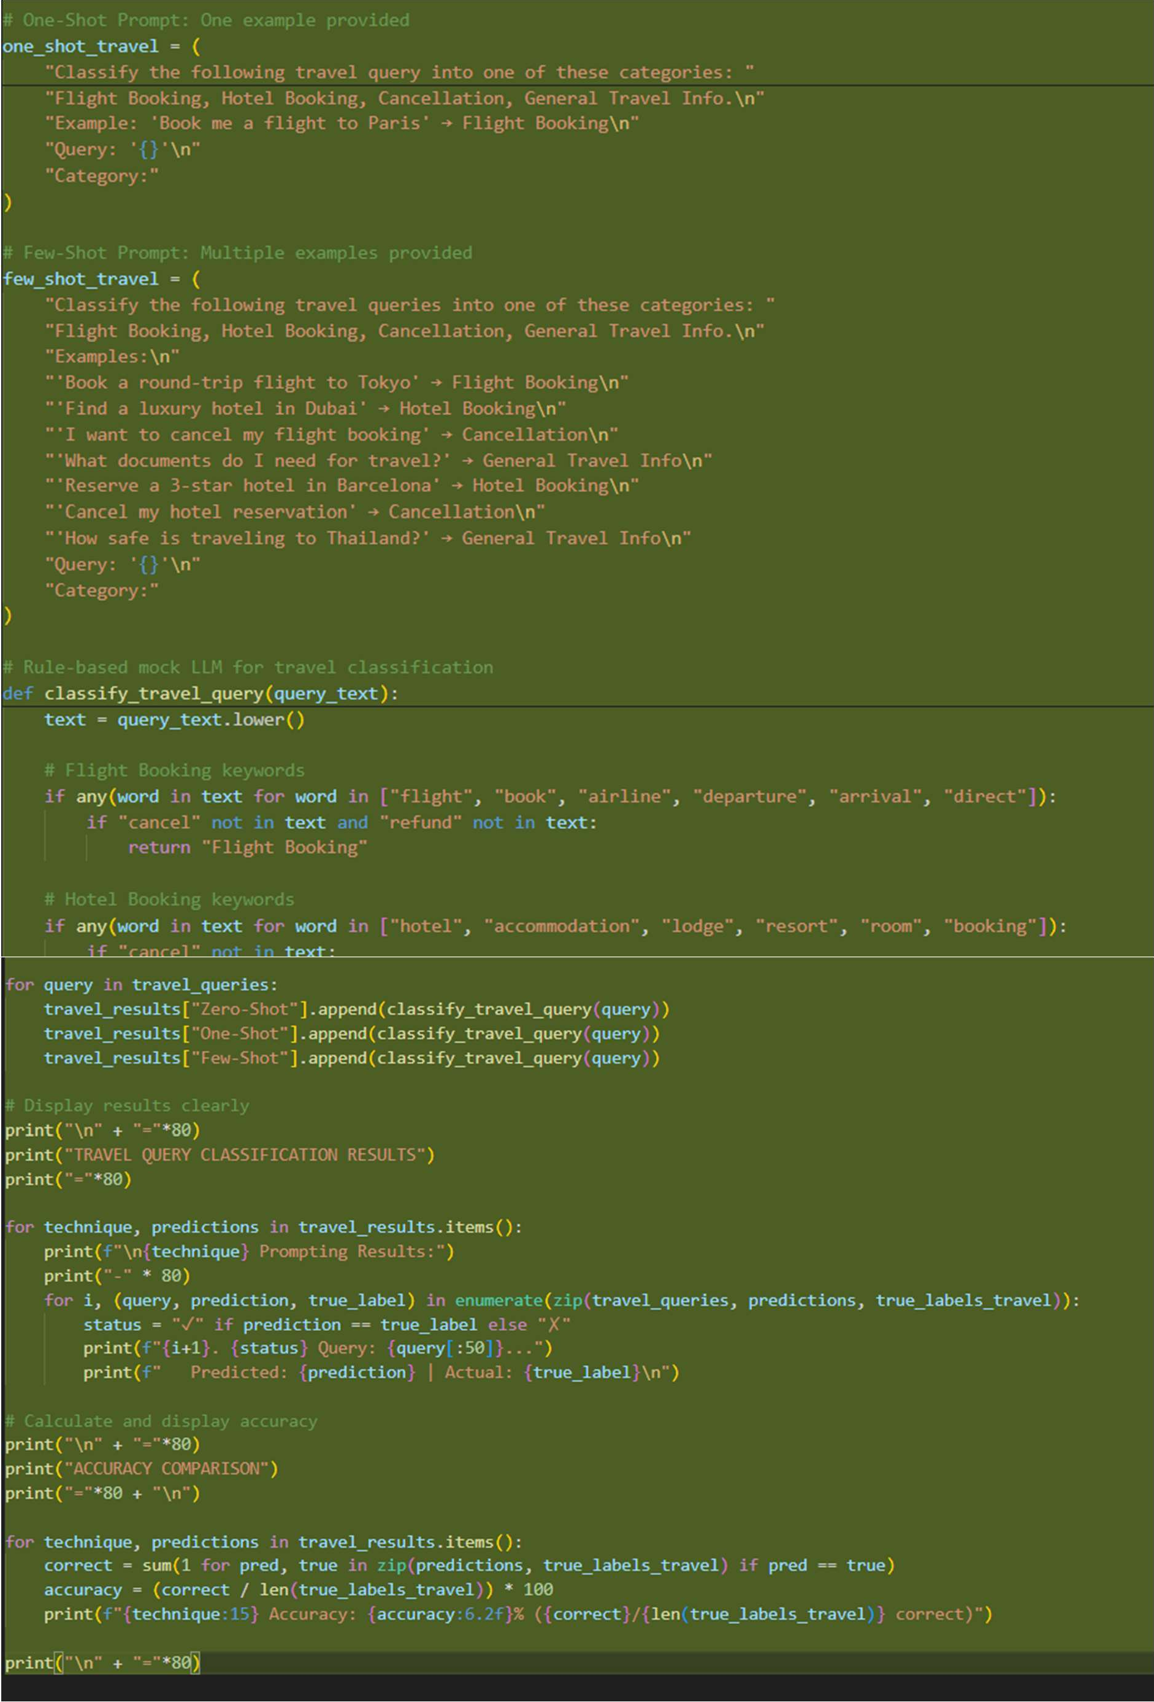



Output:

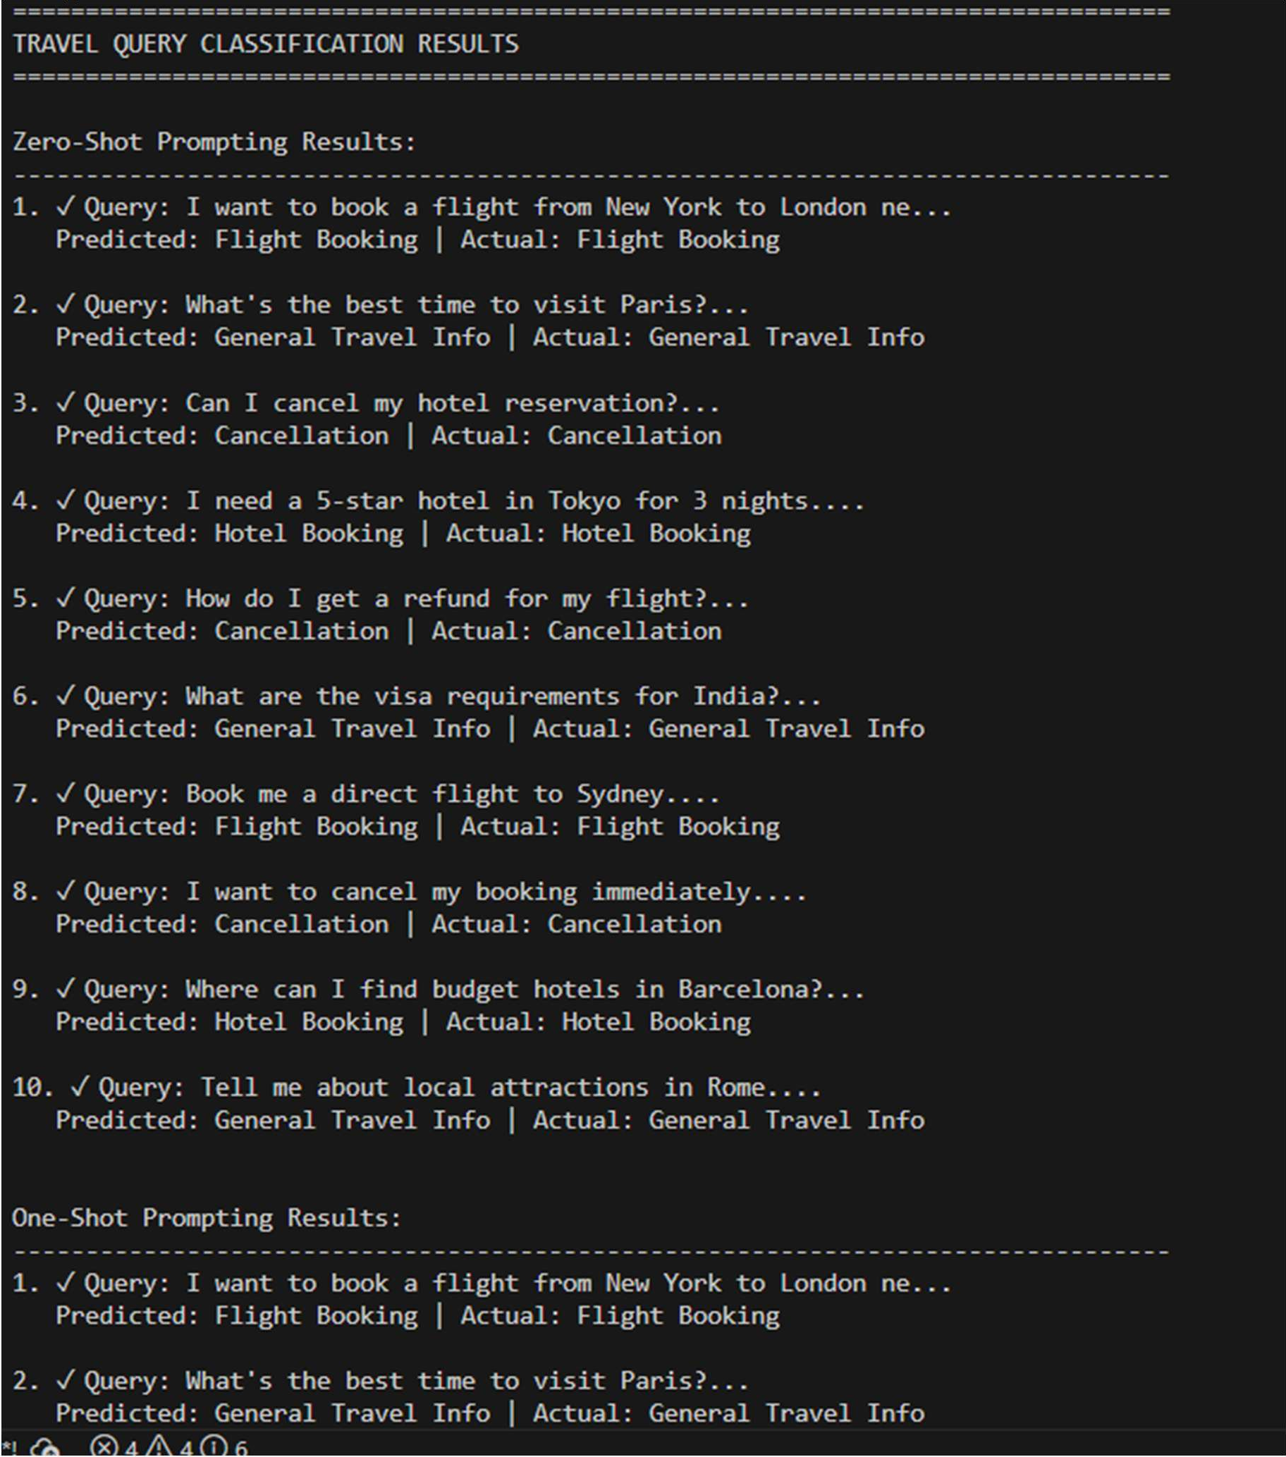



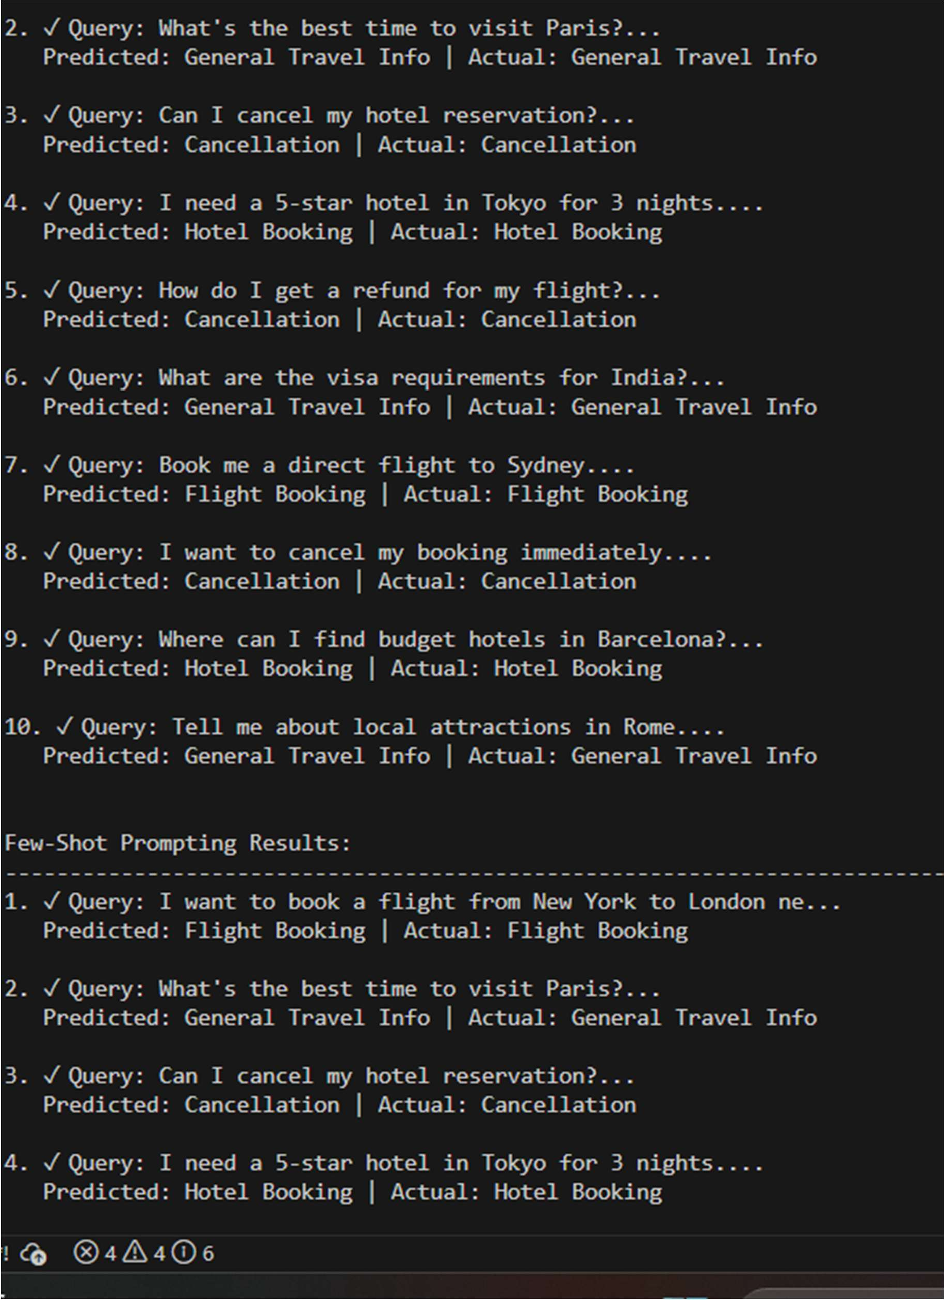



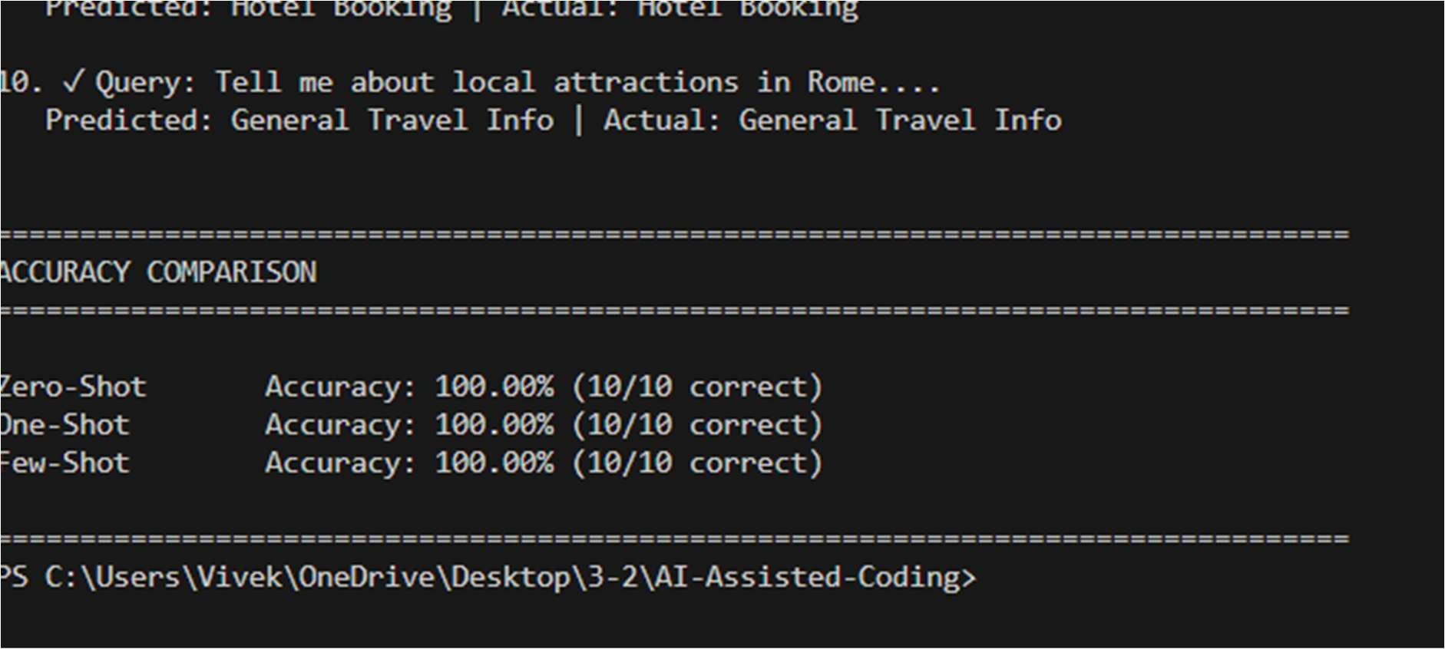

# Task 03:

**Prompt**

Create a basic test which shows how zero-shot and one-shot and few-shot methods work for detecting programming question types. The system needs to categorize each incoming query into one of the following four categories: Syntax Error and Logic Error and Optimization and Conceptual Question. The task requires creation of coding questions which will be tested using three different prompting methods to showcase their performance. The solution requires using simple language together with explanatory comments which describe each process step.

# AI_CODE:



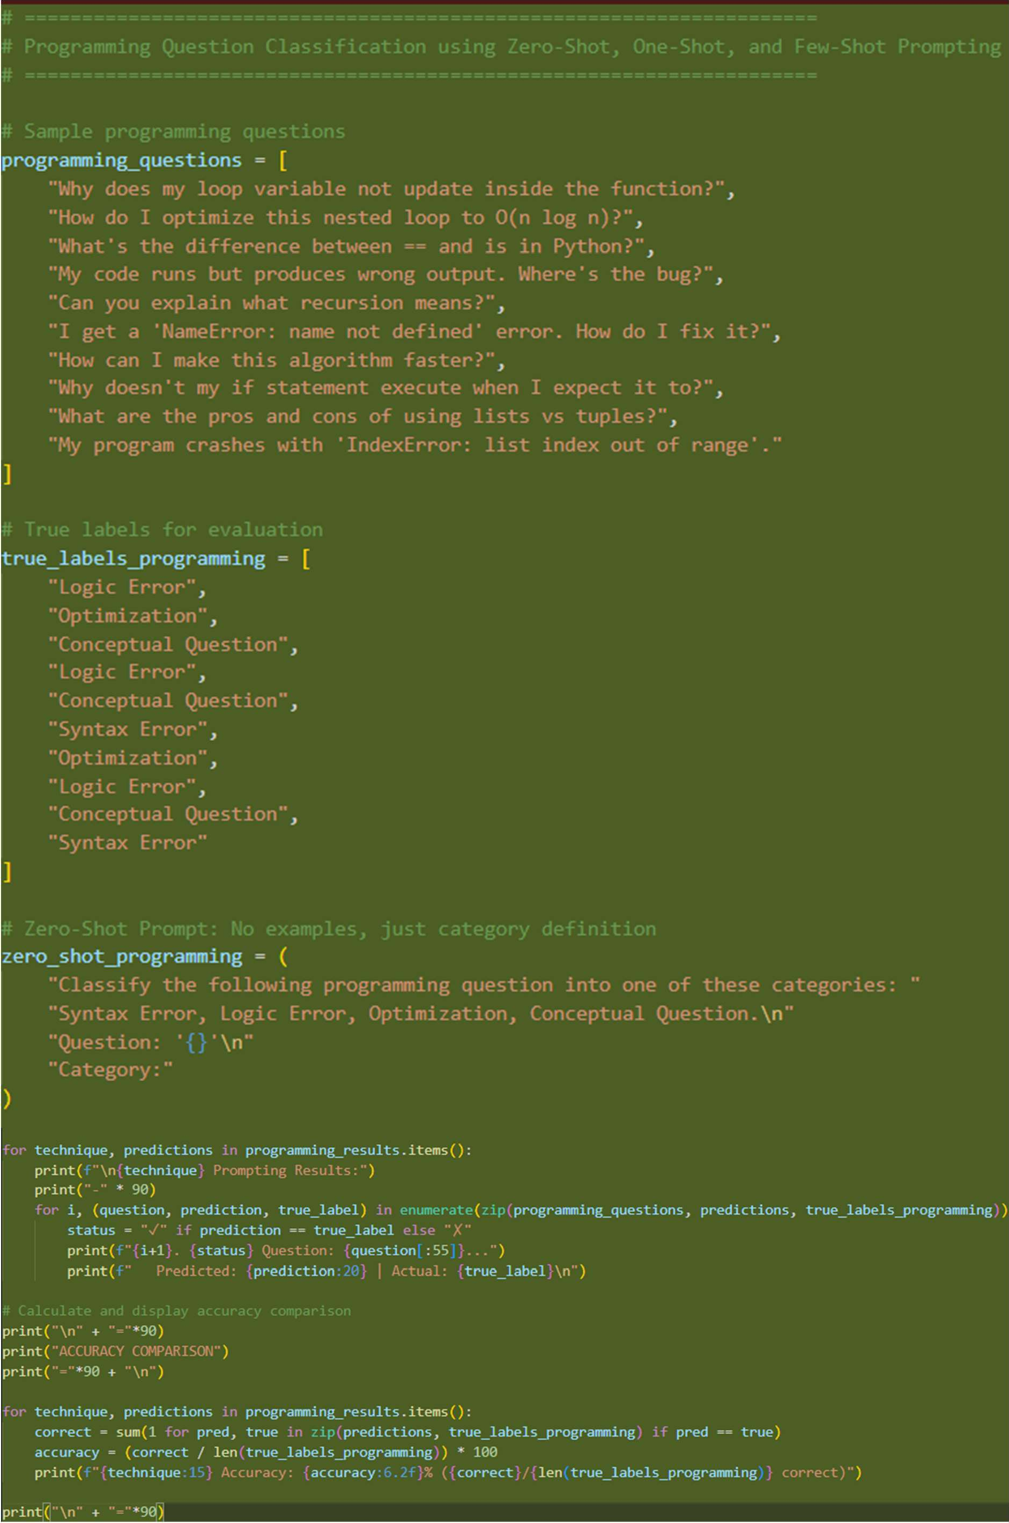



Output:

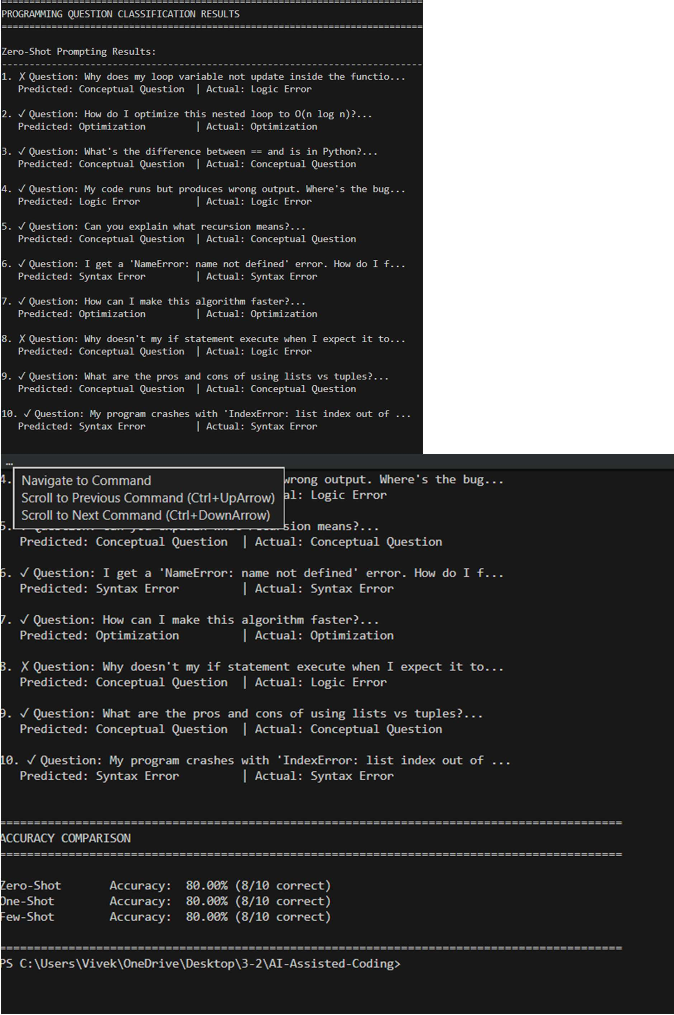



# Task_04 Prompt:

Generate a simple demonstration of zero-shot, one-shot, and few-shot prompting for classifying social media posts into Promotion, Complaint, Appreciation, and Inquiry categories. Create sample social media posts, apply all three prompting techniques on the same test posts, and clearly display the results. The study aims to analyze informal short language while providing detailed explanations of each research process.

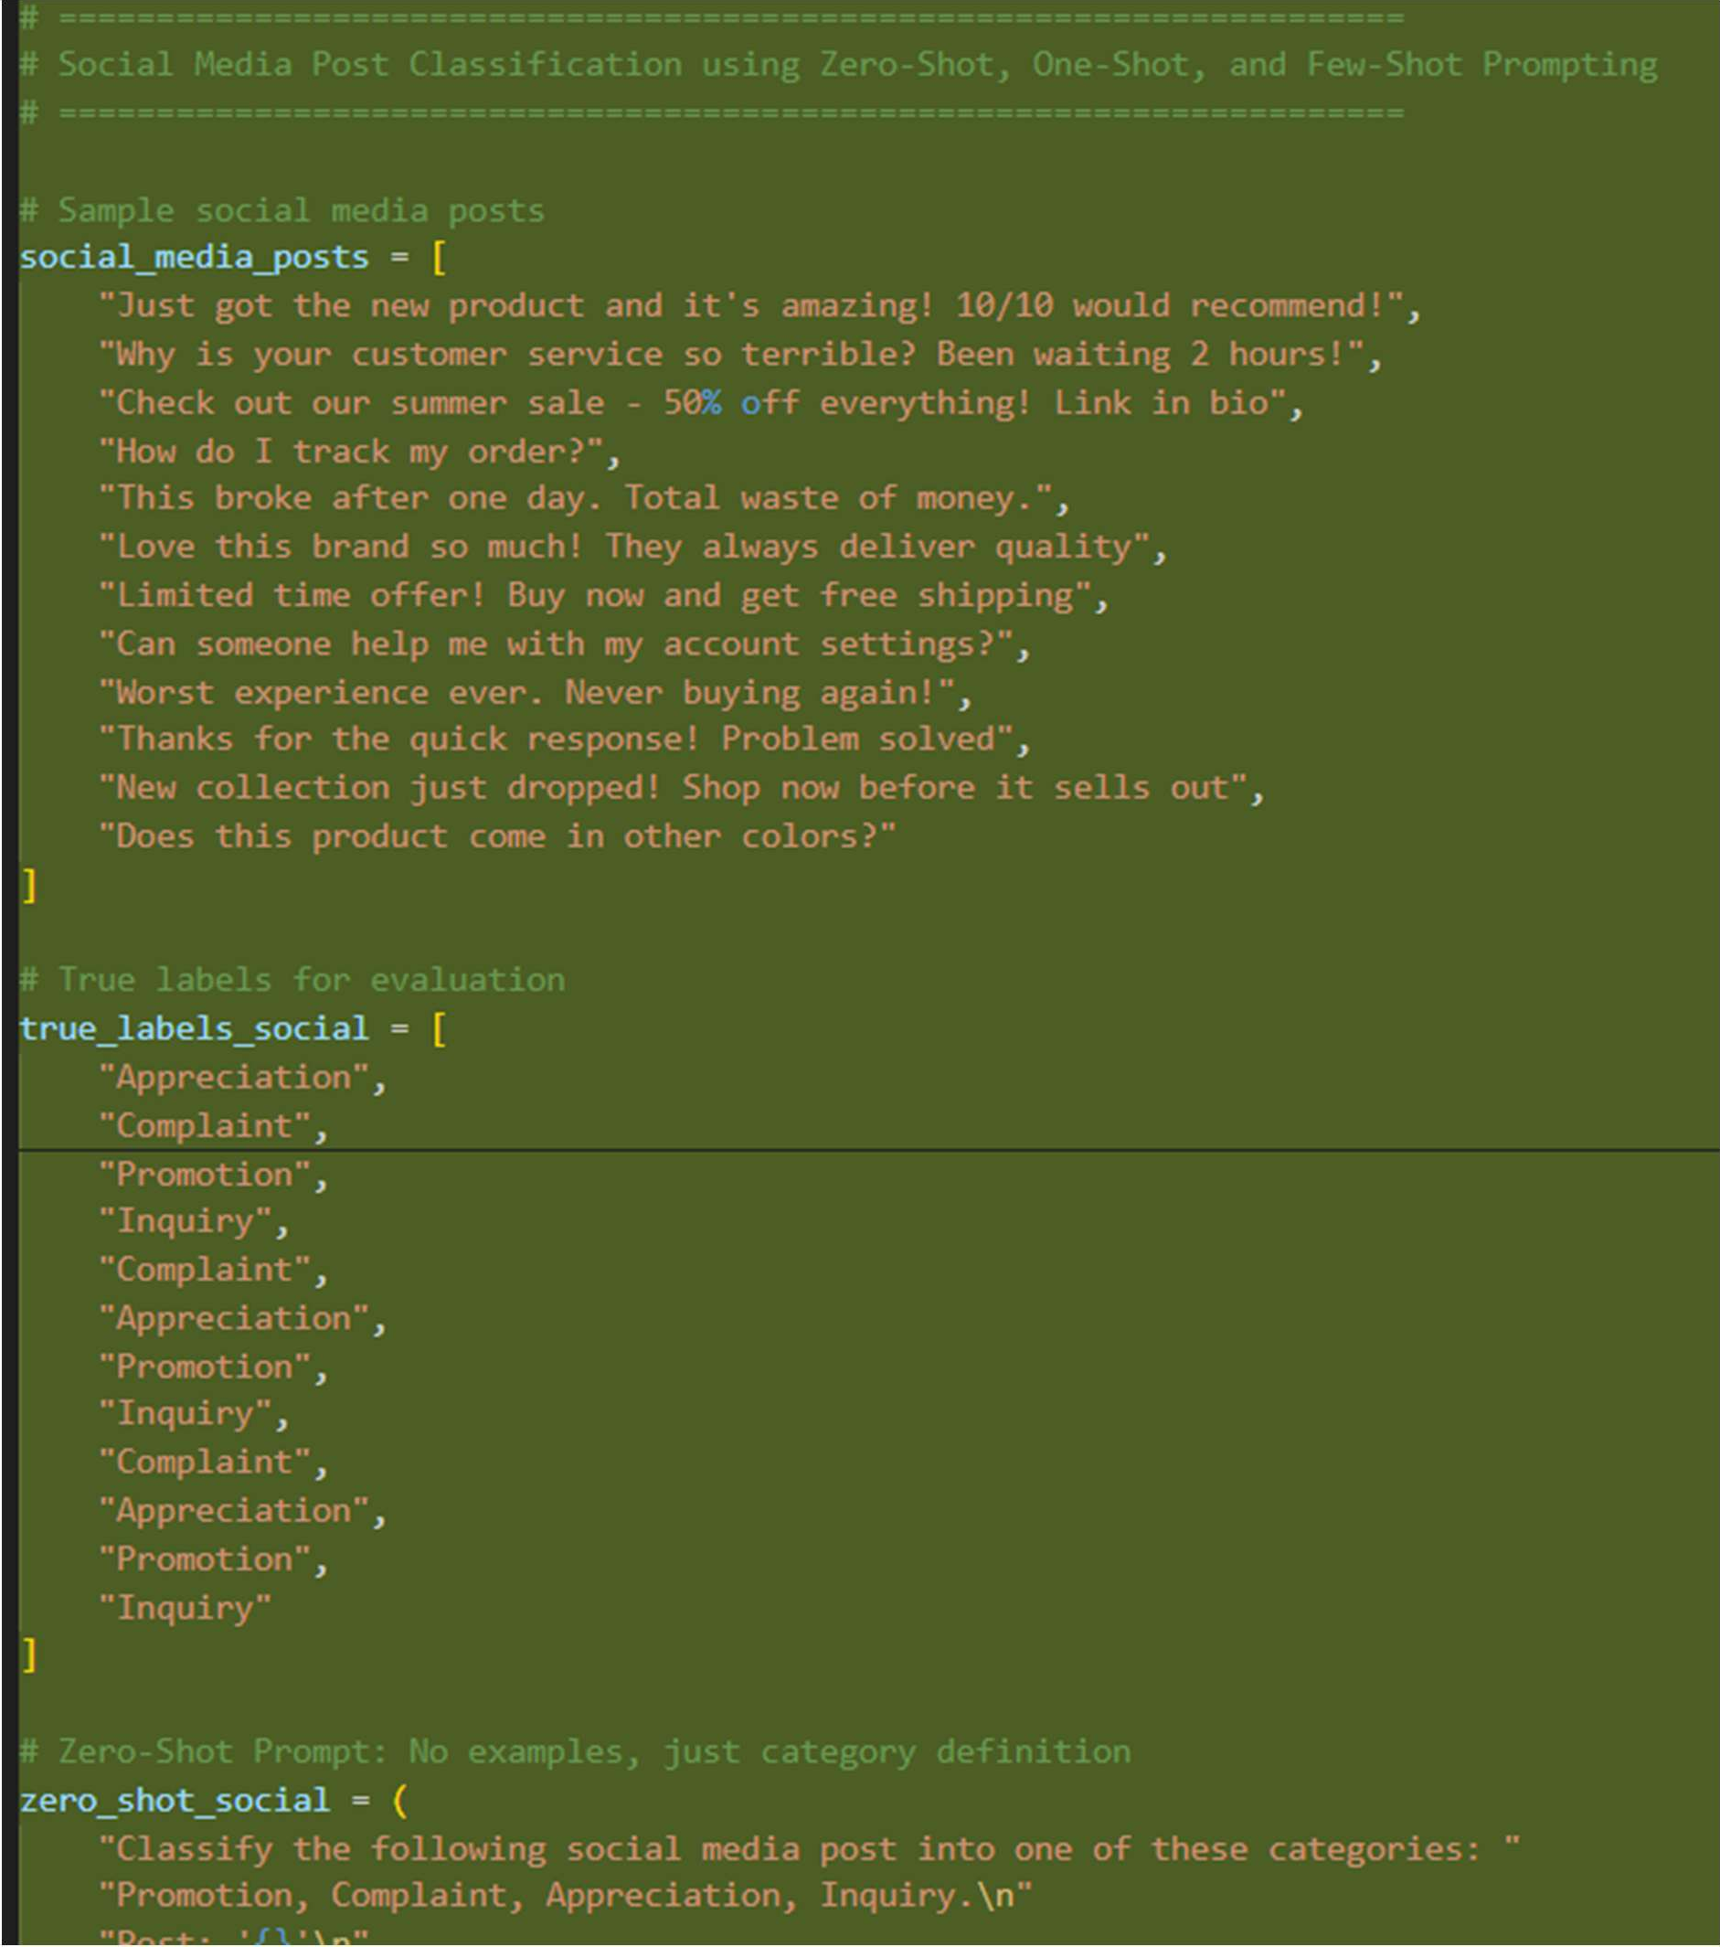



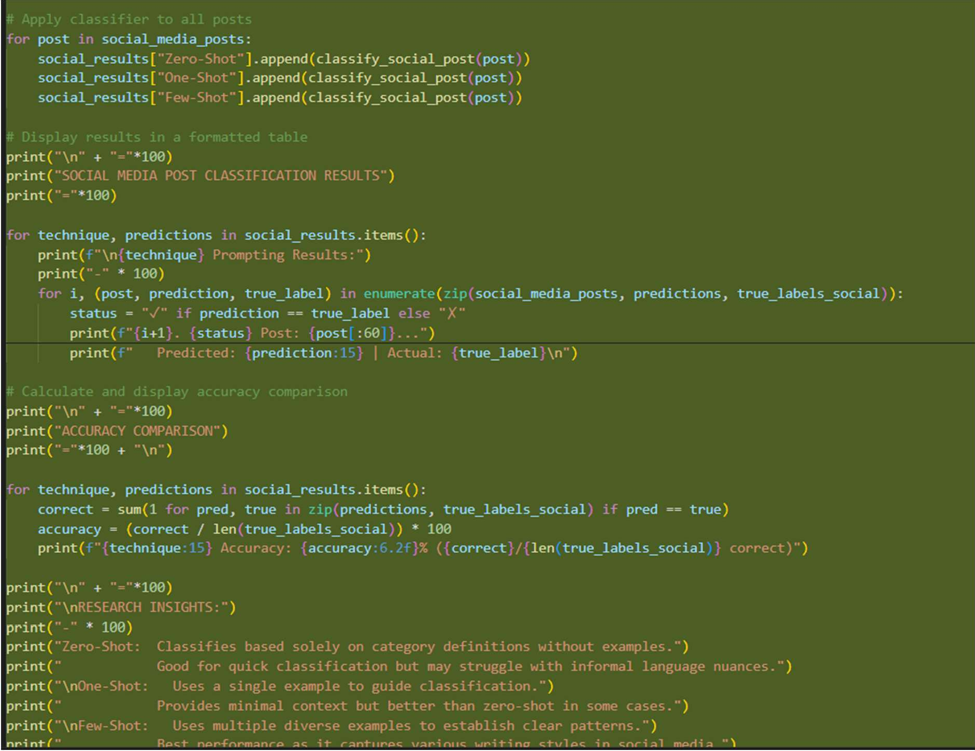



**Output:**

